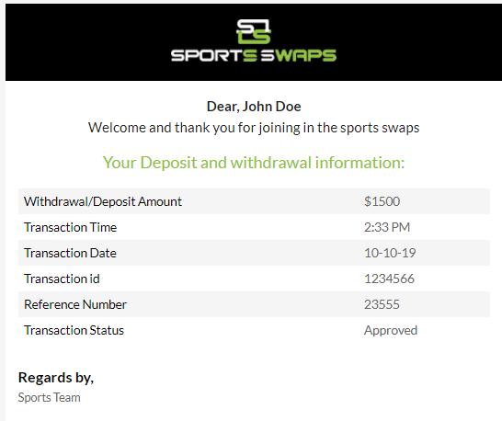

**At top for deposits should say**

Dear, (username)

Thank you for your SportsSwaps(please make this a link to our website) Deposit!

**For withdrawal:**

Dear, (username)

Below are the details regarding your SportsSwaps (please link to our website) Withdrawal.

**For deposits it will then show:**

Your Deposit Information:

**For Withdrawals it will show**

Your Withdrawal Information:

**Underneath If it is a deposit it will show:**

Deposit amount:

**Likewise if withdrawal it will show**

Withdrawal amount:

**At the bottom it will say**

Best Regards,

SportsSwaps